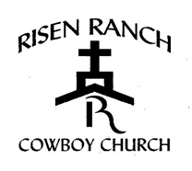
Risen Ranch Horsemanship and Bible Camp

What to Bring:
Completed Registration Form, parent or guardian must stay until registration has been signed off by Registration Leader.
Bring Bible
2 Big buckets for water and feed.
Bring hay, feed, and pooper scooper.
Camper will need bedding, sleeping bags or cots. They may bring a fan if needed.
They must have 4 changes of clothes for 2 days.
Towels, wash cloths and personal toiletries
No cell phones or any kind of electronics (leave them at home!)
No dogs

NO SHORT SHORTS, SHIRTS MUST HAVE SLEEVES AND COVERING THEIR CHESTS.
NO OPEN TOE SHOES.

Bible camp schedule for parents:
Parents must be at the arena by 9:00 a.m. Saturday for arena show. Lunch served after arena show.
It is mandatory for all campers to attend. We encourage all parents, family and friends to stay.

No camper can leave until the camp grounds are cleaned and have been released by their leaders.

